Spencer Booth-Jeffs, Mason Watson, Joshua Driver, Lachlan Reid

SmiJle Team

Project Handbook

FDLMARKS 131

FANCY LOGO

# Revision

*Use whichever style of versioning you prefer.*

*You may also include the main authors of each change, and the list of pages that have been changed*

|  |  |  |  |
| --- | --- | --- | --- |
| Version Number | Date approved | Approved by | Description |
| 1.0 | 18 – 03 - 2020 | Team Member | Initial release of plan |
|  |  |  |  |

# Preface

*Describe the purpose and audience of this document, in your own words.*

The purpose of this document is to provide a clear direction of the project, it will help us keep track of what kind of tests we have done previously to prevent any kinds of tests to be repeated again, thus, less loss of time, it is also a tool used to help share ideas with other team mates, to improve better efficiency, it helps provide a clear understanding of what kind of resources/ materials you might currently have.

The kind of audience we will be targeting towards are involved in the university are students, teachers/professors/lecturers, typically within federation, since other universities use other programs to display their grades for their assessments, exams, practicals, trails, etc. HR managers will also want to view an employee’s grades to determine the academic performance of the overall participant. This will also be used for other project users that can help them provide a direction.

Table of Contents

Revision 1

Preface 1

List of Figures 3

List of Tables 3

Vision Statement 4

1. Introduction 4

1.1 Project Overview 4

1.2 Project Deliverables 4

1.3 Evolution of the Handbook 4

1.4 Reference Materials 4

1.5 Definitions and Acronyms 5

2. Organization 5

2.1 Process Model 5

2.2 Organizational Structure 5

2.3 Organization Boundaries and Interfaces 5

2.4 Project Responsibilities 5

3. Managerial Process 6

3.1 Management Objectives and Priorities 6

3.2 Assumptions, Dependencies, and Constraints 6

4. Technical Process 6

4.1 Methods, Tools, and Techniques 6

4.2 Software Documentation 6

5. High level Project Plan 7

6. Non-functional Requirements 7

6.1 Platform 7

6.2 Communication 7

6.3 Performance 7

6.4 Security and Privacy 7

6.5 Audience, Usability and Accessibility 8

6.6 Reliability 8

6.7 Modifiability 8

6.8 Economic 8

6.9 Legal 8

6.10 Standards 8

6.XX Other Non-Functional Requirements 8

7. Software and Systems Architecture 8

7.1 Architecture objectives 8

7.2 High-level architecture 8

7.X System context 8

7.X User Interface / Interaction Design 9

7.X Data model and software design 9

7.X Assumptions 9

7.X External Dependencies 9

7.X Concept art, storyboards 9

Additional Components 9

Index 9

Appendices 9

# List of Figures

**No table of figures entries found.**

# List of Tables

**No table of figures entries found.**

# Vision Statement

*Overview*

*The purpose of the vision statement is to clearly identify the project goals. How will the product you are producing benefit your client/stakeholders? Who will use this product? What features are critical? How will this product be differentiated in the market (if applicable) Keep it short and concise however, make sure that you identify everything that the product will accomplish. You can expand upon this in the introduction. (See Satzinger et al. page 13)*

The goal of this project is to help improve the Fdl marks website and to help create a new phone app for good convenience, the people at the university will help us provide the data required to help us simulate the overall final product and will be providing code for the web browser edition of the latest product. Fdl marks also helps provide a study plan which can only be accessed through the web browser, the downfall of this is that the amount of time that it takes to get to opening your laptop and to getting to the actual application itself would take such a long time in which students wouldn’t have that kind of attention span that they would not bother continuing.

“The aim of this project is to enhance the functionality and accessibility of fdlMarks via the development of a mobile app, to refactor the code that is currently utilised, and ensure that both the current web-based application and the new mobile app are secure.”

To solve this problem, the administrators have come up with an idea of a mobile app that can not only provide a quick service to the study plan, but to be able to create a faster service to view your grades as soon as the marks are out (maybe a notification for quicker access) we also want to enhance the look of the overall web based Fdl marks as it does look a little bit out of date. Small changes will also be needed to optimise the app for phones because of the substantial screen difference between phones and laptops.

The people that will be using this product are students (To view their overall progress, to be able to view their descriptions), lecturers (to be able to edit grades or to create a new grade bio or criteria) , and HR managers (To view the academic progress of the persons performance).

I think this will help with providing the students the capabilities of being able to organise certain objectives faster and efficiently, plus, this will help with saving students a lot of money, since students are statistically broke so there wouldn’t be any kind of requirements of buying a book or an “organiser”, this will also help boost the universities rankings and staff morale between the stakeholder and the teacher.

The most critical features that are most required is the code refracturing, which can help the project make the program more effective and faster, it will also take the longest to complete since we don’t exactly know what ticks or how things are effective. We also need it to be able to display grades based on the data on the Database, when we update the data, the latest data should be able to be displayed on the UI.

After meeting with the client, it has been revealed that instead of building an application it is a larger priority to focus on the functional requirements(EG the code re fragment) and adding comments to the code to improve understandability than it is to build an new application the client is more than happy if we just improve and optimise the current system in place

Code so that we can better improve the overall product, satisfying both the student and the teacher.

# Team meetings

[*https://web.microsoftstream.com/video/25dbe3bf-3f29-4950-a1bc-9b76aa506ed6*](https://web.microsoftstream.com/video/25dbe3bf-3f29-4950-a1bc-9b76aa506ed6) *Week 2*

[https://web.microsoftstream.com/video/3f995401-1e47-40fc-a9de-675377e4a209 Week 3](https://web.microsoftstream.com/video/3f995401-1e47-40fc-a9de-675377e4a209%20Week%203)

Week 4 (Corona Incident)

<https://web.microsoftstream.com/video/229fbe38-a5cb-4100-a328-9668ab94f96b> Week 5

1. Problem Description
2. System Capabilities
3. Business Benefits

# Introduction

## 1.1 Project Overview

*Give a* ***summary*** *of the project objectives and deliverables, and any other work that required as part of the project.*

*Include a brief description of the resources required, deadlines, and budget.*

## The deliverables that can be completed are to create a code that is well organized and can be looked back at again and can quickly be distinguished and to understand what each function of the code does. Another deliverable is to re-create the code and remove any kind of code that is not required due to better technology and to use that technology to improve upon that code, we can also provide a phone web base compatibility using the CSS files and HTML files provided by the user.

## The resources that we will need to provide these deliverables, is the HTML and CSS file, we are also required the source code of the Database file, we will also need the Virtual Machine to be able to interact with the database and to provide the programming editing applications. There shouldn’t be any kind of budget within the project as the resources are already provided to us by the client.

## 1.2 Project Deliverables

*Describe what items are to be delivered to the client, approximate dates, and quantities (if any).*

*You do not need to include process documentation (such as sprint documentation, design documents, or similar) here, but should include a user manual, an installation manual, and technical documentation.*

## 1.3 Evolution of the Handbook

*Plan for making scheduled and unscheduled updates to this handbook. How will you keep it up to date?*

*Consider:*

* *When will scheduled updates happen?*
* *Who is responsible for updates?*
* *How will you put the handbook in change control?*
* *How will everybody be notified of handbook changes?*

So updates will happen if circumstances are dramatically changed we will also keep the old updates and bookmark the new update onto the booklet as it is important for the other team mates to know where we currently are in progress and what currently needs to be done further on into the handbook, most updates will be responsible to the development manager whom is Spencer Booth-Jeffs, who also has the final say of the development.

So the best way to be able to put the handbook in change control is to make careful decisions of the project and provide a schedule of when we can constantly update the handbook this can help with managing the amount of time we put onto the hand booklet and focus on other processes that need to be done.

## 1.4 Reference Materials

*This is a complete list of materials referenced elsewhere in the handbook, such as style guides, coding standards, documentation standards, methodologies, etc.*

*Indicate if you haven't used any external references.*

*Use any style that you like. If you don't know any good ones, then use IEEE or APA style*

APA Style. (2012). Retrieved 31 March 2020, from <http://www.apastyle.org/>

fdlGrades --> Federation University Australia --> Log In. (2020). Retrieved 31 March 2020, from <https://fdlgrades.federation.edu.au/>

IEEE - The page cannot be found. (2020). Retrieved 31 March 2020, from <http://www.ieee.org/documents/ieeecitationref.pdf>

Wale, S. (2020). Product Backlog Template - How to Build and Prioritize Agile Product Backlog?. Retrieved 31 March 2020, from https://www.techno-pm.com/2016/09/product-backlog-excel-template.html

## 1.5 Definitions and Acronyms

*Define, or provide references to the definition of, terms, acronyms, or abbreviations used in the handbook.*

|  |  |
| --- | --- |
| Term | Definition |
| SP | Study plan – A function featured within the FDLmarks |
| FDL | FDL – A shorter term for the FDLmarks. |
| FR | Functional Requirements |
| NFR | Non- Functional Requirements |

# Organization

## 2.1 Process Model

*This section should describe how the project functions and activities (ie. the work you are doing) work together to build your project.*

*You should include a high-level breakdown of the activities, with a rough timeline. Include a chart, diagram, or timetable. You should indicate this at the level of* ***each sprint****. For each sprint, clearly state the outcomes and deliverables to be produced.*

*Include preliminary agreed dates for sprint review meetings for demonstrations to your client.*

*As this is an agile project, this is necessarily a projection/estimate rather than a binding timeline.*

## 2.2 Organizational Structure

*Describe the structure of the project team, from a* ***process perspective****. Identify scrum roles, and how you will determine changes in these roles.*

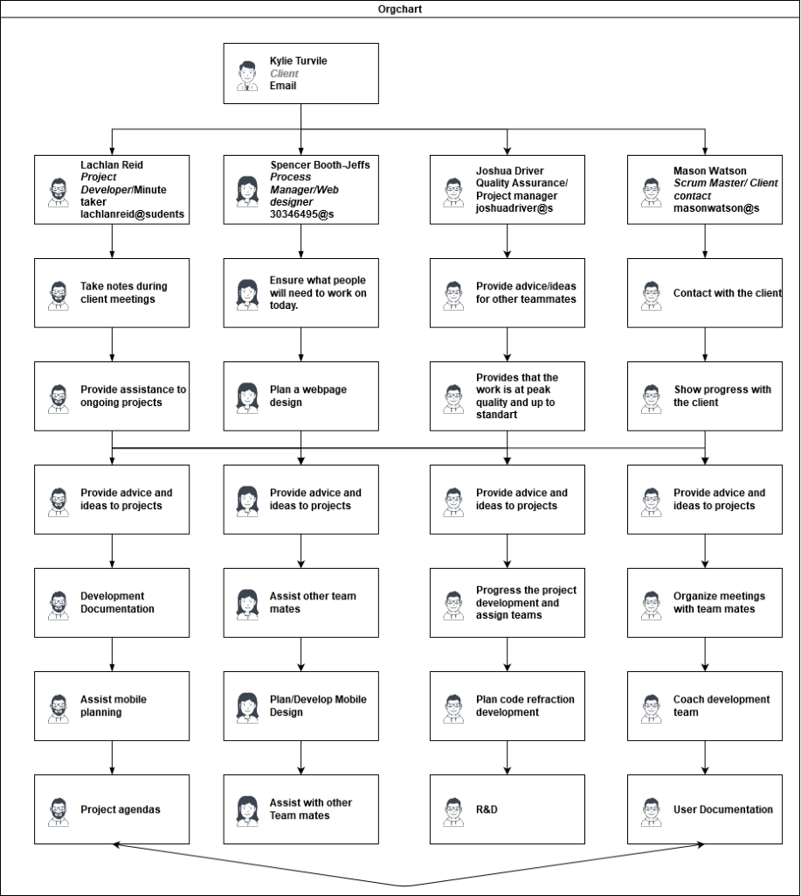

## 2.3 Organization Boundaries and Interfaces

*Describe the "administrative and managerial boundaries" between you and your client, and other stakeholders or contributors.*

*Be specific – indicate people and their roles – the more specific you can be the more useful you will find this document.*

*How will client communication be handled, who will be responsible, how often will you be in contact?*

1. *Communication and Social*

1.1 Because of Covid-19 we cannot meet with our client face to face.

1.2 Client can only be contacted during business hours.

1.3 Meetings must work around her schedule.

1.4 All team members have jobs and other commitments

1. *Data sets*

2.1 Most of the coding for the data is all over the place, making it hard to interpret

2.2 Some data sets are in 7 different php files, which means it might take a bit longer to be able to get the code on time

1. *Security and Privacy*

3.1 Some of the data has information that cannot be released to the public or the development team. (Which is being worked on by another development team)

## 2.4 Project Responsibilities

*Describe the* ***non-procedural*** *roles of each of the team members – for example who is responsible for design, programming, artwork, quality assurance and testing, user documentation, technical documentation, etc.*

*You can use a matrix if the team members share responsibility for each function (which is recommended).*

# Managerial Process

## 3.1 Management Objectives and Priorities

*What is the management philosophy? Are you aiming for high performance, high equity, flexibility, or learning new skills? Sometimes you will need to choose, so how?*

*This is also good place to address conflict resolution, consider how you will handle interpersonal problems and how you will resolve them.*

As a project process manager. They thrive on the employees proactiveness and the ability to be able to do things on time, they must also be able to engage in problems that might occur with the employee such as poor communication and mishaps.

As a Code Developer the number 1 role to respectively work on my part of the code and any problems will be discussed with the team and provide the best solutions amongst the others

The strategies which I use will be following by an example route, this provides the strong motivation and strength of the team under each individual manager.

We believe that by developing each work product should be verified by all team users and are submitted by each team member to ensure that we provide clearance that we all agree to the product and it is at our expectations.

We believe that there are no such things as a stupid question and that we encourage creativity, prosperity and inspiration as it is the key to success.

We believe that user feedback is also an important key to the efficiency and usability to our products as they are the stakeholders, we are the ones who help develop a product for the people (users, teachers and Co-ordinators).

## 3.2 Assumptions, Dependencies, and Constraints

*State:*

* *The assumptions upon which this project is based*
* *The external events or inputs that the project depends on*
* *The constraints under which the project is operating, for example budgetary, staffing, availability, hardware.*
* Most of our constraints come from the virus which meant we aren't able to meet face to face,
* Lack of database due to the amount of work load the university has to work for, this affects us greatly as we don’t know what is within the project and we cannot start without the data
* Kylie unavailable been more busy than usual due to the virus
* All the privacy data is being worked on during our 1 st sprint but we can't help or speed it up as it is something that is out of our hands.

# Technical Process

## 4.1 Methods, Tools, and Techniques

*Detail the tools and techniques used to build the project – note that this isn't necessarily limited to the target platform, but includes your project management, documentation, and communication tools.*

*Describe your team's implementation of the Scrum framework. If you like, you may refer the reader to external documents.*

*What tools will you use to handle* ***communication*** *within your team?(e.g. MSTeams)*

*How will you specify and model your* ***software designs****?*

*Which* ***document and code management*** *systems are you using?(e.g. MSTeams, github)*

## 4.2 Software Documentation

*What is the plan for creating user and technical documentation?*

*You will need to plan for the creation of a User Manual and an Installation Manual*

*How will documentation be reviewed and tested for accuracy?*

*Will you use a style guide? If you use an external guide, be sure to include it in your references.*

# High level Project Plan

*Identify how many sprints are planned for the project. For each sprint, identify the sprint goal – the key objectives that you forecast achieving in that sprint. For each one,* ***indicate how you will evaluate it as successfully ‘done’*** *(this is a bit like a high level condition of satisfaction). “The sprint goal is an objective that will be met within the Sprint through the implementation of the Product Backlog, and it provides guidance to the Development Team on why it is building the increment.” (The Scrum Guide, p10)*

*You may decide that in the first sprint, you are doing some research and building a prototype to demonstrate what is possible with some particular technology, or you may plan that you will build a particular component of your product that is key and high priority. In true agile, in each sprint, you should be developing an increment or release of your product or some deliverables relating to your project. In the context of the learning experience and as you are students without significant experience, you may plan to focus on some early design decisions in your first sprint, but* ***please ensure you identify clear goals and outcomes for each sprint.*** *So, it may be that you are designing a database, but don’t stop at an E-R diagram, design the database and then create an implementation of the database and some queries that are useful for achieving key objectives relating to your product. Alternatively, it may be that you are designing a level for your game, so identify (some of) the characters, (some of) the scripts and behaviours and then implement (part of) that level.*

*At the beginning of each sprint, you will revisit this plan and then build your product backlog items to identify specific tasks to be completed during the sprint. During each sprint, you should be engaging in design, development and testing.*

*“Having set the Sprint Goal and selected the Product Backlog items for the Sprint, the Development Team decides how it will build this functionality into a “Done” product Increment during the Sprint. The Product Backlog items selected for this Sprint plus the plan for delivering them is called the Sprint Backlog… As the Development Team works, it keeps the Sprint Goal in mind. In order to satisfy the Sprint Goal, it implements functionality and technology. If the work turns out to be different than the Development Team expected, they collaborate with the Product Owner to negotiate the scope of Sprint Backlog within the Sprint.” (The Scrum Guide, p11)*

*You may provide a link referencing your online project board (e.g. in GitHub project board or Trello board) here.*

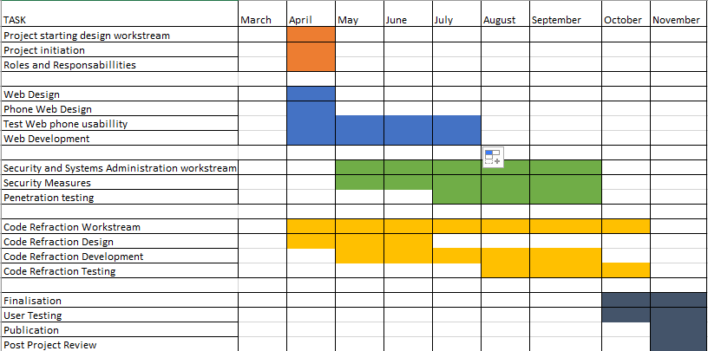

# Non-functional Requirements

*For each of the following section headings, identify any relevant non-functional requirements. For each one,* ***indicate importance*** *and* ***how you will evaluate it*** *(this is a bit like the conditions of satisfaction and makes sure you can measure your success)*

*Don't include spurious requirements just for the sake of it!*

*If your project has no relevant non-functional requirements for any of the following domains, leave the section heading in-place and indicate that there are no applicable requirements.*

## 6.1 Platform

The fdl marks website must be tailored to be more usable on android devices. This is one of the main goals of the project and will be successful if students are able to comfortable use fdl marks on their mobile devices.

## 6.2 Communication

Fdl marks will need to be able to successfully work and integrate with fdl grades. This is moderately important as it is one of the deciding factors as to whether the client will actually use the end product as is, however, it isn’t the main goal that the project hopes to satisfy. It will be successful if the system is able to seamlessly integrate with fdl grades.

## 6.3 Performance

The database will need to be optimised so that it functions more efficiently on the universities servers. This is of low importance as the project doesn’t directly aim to improve performance but by refactoring the code of the existing system performance should hopefully improve regardless. This will be a success as long as any sort of performance increase is achieved.

## 6.4 Security and Privacy

University student’s grades will need to be secure so that they are unable to view other student’s grades and unauthorised people are not able to view their grades. This is of very high importance to the system as any leakage of information could be catastrophic. This will be successful if the security put in place is able to protect the information of university students.

## 6.5 Audience, Usability and Accessibility

University students need to be able to use fdl marks on their mobile phones to comfortably look at their results and their study plan. This is of high importance and ties in with the platform, with the measurement of success being the same. International students will need to be able to read and understand their grades and study plan on fdl marks. This is of low importance and is just an extra goal for the project to meet but lies outside of its main goals. It will be successful if any sort of other language is implemented.

## 6.6 Reliability

Students will need to be able to trust fdl marks to reliably present them with their grades. This is of high importance as miss reporting of grades to a student could either lead to unnecessary anxiety or confidence. This will be a success if the database correctly supplies students with the correct information.

## 6.9 Legal

The system will need to adhere to privacy and security laws in regard to student’s information. This is of moderate importance as while we will try to improve upon the system, the final implementation of the system is ultimately up to the client, and while we are working on the system this doesn’t apply us much to the project.

## 6.10 Standards

The system will need to adhere to the standards set by the pre-existing database and the pre-existing system. This is of high importance as if we don’t follow these standards the system, we change might end up becoming incompatible with the existing system. This will be a success if all standards are followed.

## 6.11 Documentation

The back-end code for fdl marks will need to be modified such that is both more readable and that it is also documented better. This is of high importance as this is another one of the projects main goals. It will be successful if all of the back end is refactored with appropriate comments in the code and further documentation with explanations on how the system functions.

# Software and Systems Architecture

## 7.1 Architecture objectives

*Describe the desired properties and goals of your system architecture. You may refer to the above non-functional requirements where necessary. This section should be only a paragraph or so.*

## 7.2 High-level architecture

*Describe the overarching design of the system, or at least your current plans for the architecture. Examples of your software and systems architecture might be* ***n-Tier****,* ***distributed****,* ***microservice****,* ***monolithic, Model-View-Controller, Model-View-View-Model*** *or a combination of several of those.*

***The following sections are un-numbered as you may not need to include some, depending on your project. You should number sections appropriately***

## 7.X System context

*Where does your system fit in with other systems? How and why does it interface with them? How is responsibility for functionality split across systems?*

## 7.X User Interface / Interaction Design

*Include initial user flows, visual designs, mock-ups, concepts, sitemaps, or any other appropriate documentation to show how you anticipate users will interact with your system*

## 7.X Data model and software design

*Describe your initial database design, using diagrams or data dictionaries. Indicate if you are using any standard data design patterns or conventions.*

*If you are designing a file format or new data structures, describe the format, your justification for its design, and similar formats.*

*You may include other types of system design diagrams here too; choose whichever diagrams best suit both your project and your team's design process.*

## 7.X Assumptions

*You may make certain assumptions about your target platform/system when creating your design. Indicate those assumptions here.*

*Examples might include number of users, frequency of use, software libraries, available bandwidth, database size, hardware revisions (ie which phones does your app work on?)*

## 7.X External Dependencies

*These are external dependencies in the architectures – for example are you relying on third-party systems to remain available? Library or operating system code which you can install permanently is not a dependency for this section.*

## 7.X Concept art, storyboards

*For game and multimedia projects, include appropriate concept art, character designs, treatments, storyboards, etc.*

# Additional Components

*Include any other components here that you think are necessary, such as training plans, data conversion plans, maintenance plans, etc. Number each new section as above, starting at section 7*

# Index

*An index is optional. If you choose to include one, explore whether your word processor can do so semi-automatically for you.*

# Appendices

*Any supplemental items (such as change request forms, etc) that do not form part of the handbook proper should be included as appendices.*

*https://web.microsoftstream.com/video/25dbe3bf-3f29-4950-a1bc-9b76aa506ed6*